**Master Functional Document**

|  |  |
| --- | --- |
| **Application** | NGERP - Centra |
| **Service Bundle** | Master Management |
| **Service Request** | Session Audit |

**Description :**

Session Audit Master is Used to monitor the login activity of the user. User details such as change of parameter, transactions made and windows visited by that user is logged in this master.

**Workflow Process :**

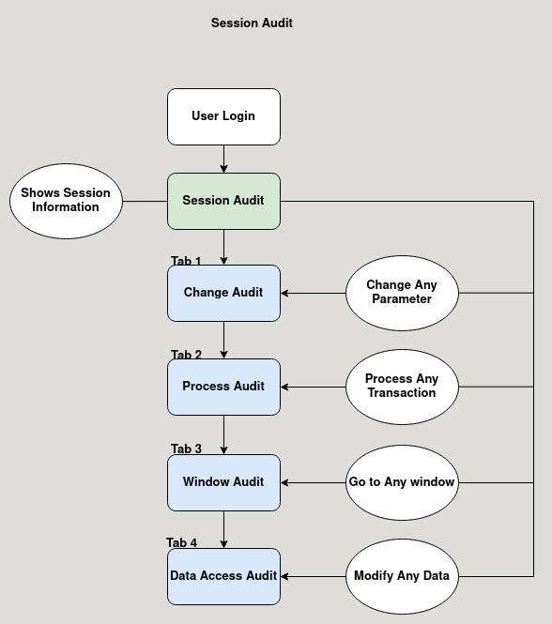

**Business Rules :**

* This master is not editable in both HQ and Region.
* Session Audit Master is Used to monitor the login activity of the user.
* It show the information like who logged in, when they logged in, their IP Address, session ID and how much time they have spent in the application on that session.
* There are four tabs in the session audit Master:
  + Change Audit
  + Process Audit
  + Window Audit
  + Data Access Audit
* **Change Audit:**

This Tab Logs the Changes made in any parameter by showing old value and new value.

* **Process Audit:**

This Tab Logs all the Transaction made by that user.

* **Window Audit:**

This Tab Logs all the window the user have visited.

* **Data Access Audit:**

This Tab Logs the Modification in any parameters.